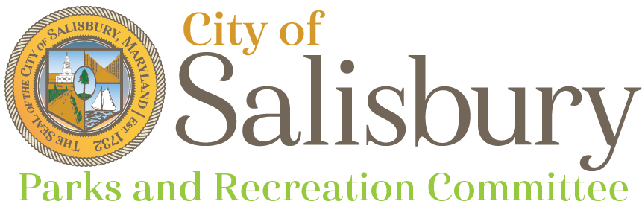
Meeting Agenda

Tuesday, June 19, 2018

5:30 p.m. – Robin’s Nest Park – 310 Gay St.
- Call to Order
- Park Tour & Discussion
- Adjournment
Next Meeting
- July 17, 2018 – Naylor Mill Forest Trails – 711 W Naylor Mill Rd
Upcoming Events
- National Night Out – City Park – August 7, 2018 – 5-8pm
- National Folk Festival – September 7-9, 2018

